PORTOLA PARK SURVEY

The La Habra Community Services Department is working hard to serve our community and we need to hear from you! Your input will help us focus on potential resources and opportunities that will have the greatest impact at Portola Park. Thank you in advance for sharing your thoughts and ideas! Please share this survey with others in the community!
English
https://www.surveymonkey.com/r/GQHZVXT
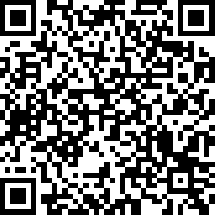
Spanish
https://www.surveymonkey.com/r/GMTJZRP
